Partial / residual correlation: AUDUSD and NZDUSD
Method 07 / daily log returns / leave-currency-out USD factor / Alpari D1 full available history

Study setup
Logical pair: AUDUSD , NZDUSD
Broker symbols: AUDUSD_i , NZDUSD_i
Snapshot: 2026-11-03_majors_alpari_D1
Timeframe: D1
Matched return window: 1999-01-05 to 2026-11-02 (UTC bar dates)
Matched return count n: 7148
Dropped unfinished last bar dated 2026-11-03 UTC after a tick-volume check against the prior complete day.
USD-strength sign rule: minus log return when USD is the quote (EURUSD, GBPUSD, AUDUSD, NZDUSD); plus log return when USD is the base (USDJPY, USDCHF, USDCAD). EURGBP is never a constituent.
Control z constituents (5): EURUSD, GBPUSD, USDJPY, USDCHF, USDCAD
z_t = equal-weight mean of those USD-strength returns on the same day
Complete matched rows (Excel): AUDUSD-NZDUSD_Partial_D1.xlsx
Complete matched rows (HTML table): AUDUSD-NZDUSD_Partial_D1_data.html

Method carried forward
Partial / residual correlation regresses each matched daily log return of close, ln(close_t / close_t-1), on the same leave-currency-out USD strength factor z, then takes Pearson correlation of the two residual series. Quotes are not inverted. z is the equal-weight mean of USD-strength returns from other majors that do not share a non-USD currency with either leg; EURGBP is never a constituent. USD-strength is minus the log return when USD is the quote (EURUSD, GBPUSD, AUDUSD, NZDUSD) and plus the log return when USD is the base (USDJPY, USDCHF, USDCAD). OLS uses an intercept on each leg. rho_partial is symmetric under swap of the two symbols. It describes leftover linear co-movement after removing linear z; it is not a cause, not a lead, and not a trading signal. Daily rows are not independent and residuals are estimated, so the two-sided p-value and Fisher interval are secondary. Same-sample raw Pearson r is a side check only.

Regression on z
leg | intercept_a_or_c | slope_b_or_d | R2
AUDUSD | 3.011e-05 | -1.053975 | 0.35359672
NZDUSD | 1.766e-05 | -1.0664271 | 0.35305895

Results
rho_partial: 0.735123
Two-sided p-value: 0
Approximate 95% Fisher interval: [0.724283, 0.745599]
Same-sample raw Pearson r: 0.828711
rho_partial minus r: -0.093588

Conclusion
Over 7148 matched daily rows for AUDUSD and NZDUSD after removing a leave-currency-out USD factor built from 5 constituents, rho_partial is 0.7351 (positive, strong residual linear link in this sample). Approximate 95% Fisher interval: [0.7243, 0.7456]. Same-sample raw Pearson r is 0.8287 (partial minus r = -0.0936). Leg R-squared on z: AUDUSD=0.3536, NZDUSD=0.3531. Two-sided p under the usual independent-pairs model is 0; residuals are estimated and daily FX rows are linked, so treat p as secondary. This does not establish cause, lead-lag, or a lasting trading rule.

Charts
Daily closes
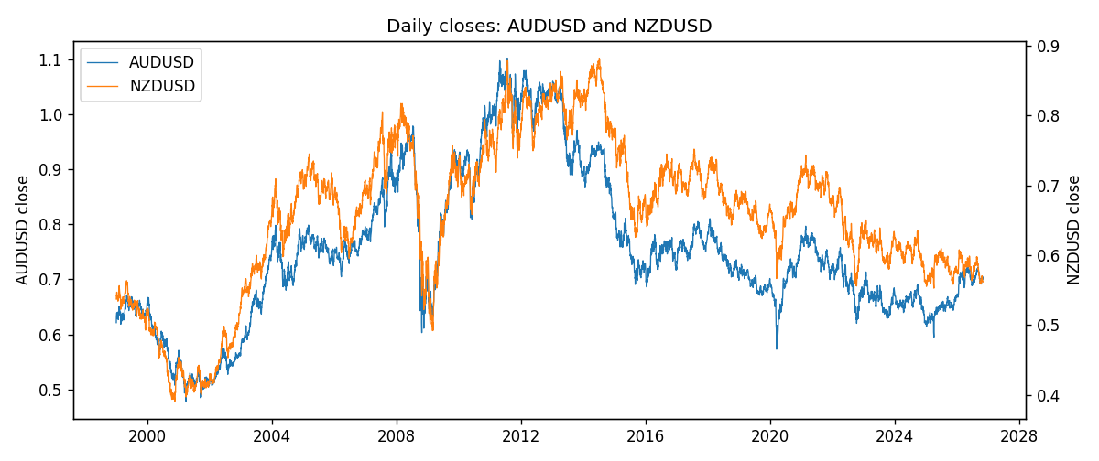
Log returns and control z
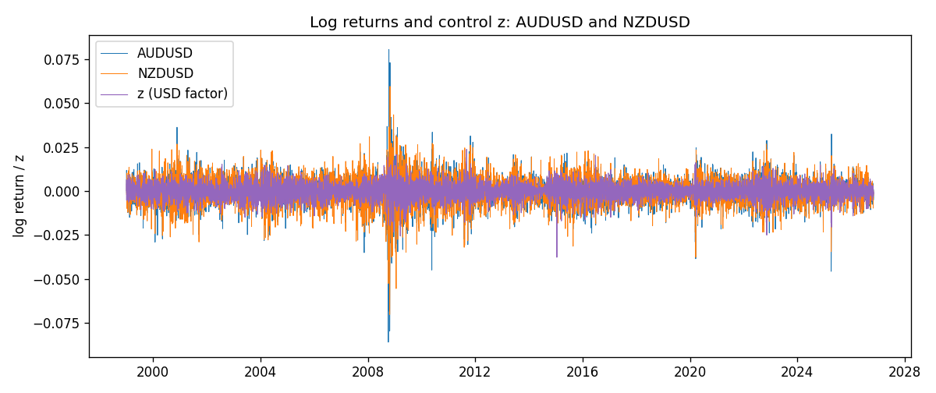
Residual scatter e_x vs e_y
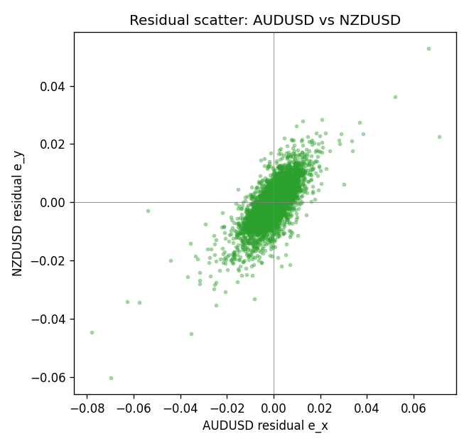

Data report
Every matched row that entered the partial correlation is stored in the sibling Excel workbook named AUDUSD-NZDUSD_Partial_D1.xlsx. That file is the complete data archive for redrawing charts. Embedding all rows as a Word table is impractical at this length; the Word file holds the column list, column summaries, and the first and last 15 matched rows.
Columns: time, AUDUSD_open, NZDUSD_open, AUDUSD_high, NZDUSD_high, AUDUSD_low, NZDUSD_low, AUDUSD_close, NZDUSD_close, AUDUSD_tick_volume, NZDUSD_tick_volume, AUDUSD_spread, NZDUSD_spread, AUDUSD_real_volume, NZDUSD_real_volume, AUDUSD_log_return, NZDUSD_log_return, usd_strength_EURUSD, usd_strength_GBPUSD, usd_strength_USDJPY, usd_strength_USDCHF, usd_strength_USDCAD, z, AUDUSD_fitted, NZDUSD_fitted, AUDUSD_resid, NZDUSD_resid
Column summaries (matched calculation rows)
column | count | mean | std | min | 25% | 50% | 75% | max
AUDUSD_open | 7148 | 0.75254463 | 0.13531821 | 0.4785 | 0.661255 | 0.7317 | 0.812135 | 1.10284
NZDUSD_open | 7148 | 0.65680048 | 0.1080291 | 0.3913 | 0.5917475 | 0.668695 | 0.72504 | 0.88218
AUDUSD_high | 7148 | 0.75660194 | 0.1358782 | 0.4878 | 0.6652025 | 0.7351 | 0.8182725 | 1.10795
NZDUSD_high | 7148 | 0.66072183 | 0.10852081 | 0.3961 | 0.595065 | 0.67222 | 0.729525 | 0.88421
AUDUSD_low | 7148 | 0.74848743 | 0.13462984 | 0.4775 | 0.65803 | 0.727775 | 0.80652 | 1.0975
NZDUSD_low | 7148 | 0.65311385 | 0.10762321 | 0.3897 | 0.588355 | 0.66451 | 0.72113 | 0.87988
AUDUSD_close | 7148 | 0.75259994 | 0.13529833 | 0.4786 | 0.6614925 | 0.7318 | 0.81193 | 1.10169
NZDUSD_close | 7148 | 0.65687963 | 0.10802405 | 0.3907 | 0.592165 | 0.66876 | 0.72518 | 0.8822
AUDUSD_tick_volume | 7148 | 77889.255 | 138502.92 | 109 | 5574 | 43696 | 71619 | 1234623
NZDUSD_tick_volume | 7148 | 69051.458 | 123370.73 | 17 | 5742 | 34119 | 58667.5 | 1127682
AUDUSD_spread | 7148 | 30.707051 | 16.89031 | 0 | 13 | 30 | 50 | 50
NZDUSD_spread | 7148 | 30.128428 | 25.588679 | 0 | 9 | 17 | 40 | 80
AUDUSD_real_volume | 7148 | 5.2809589e+09 | 1.2584371e+11 | 0 | 0 | 0 | 0 | 3.811512e+12
NZDUSD_real_volume | 7148 | 1.678526e+10 | 8.5194876e+10 | 0 | 0 | 0 | 0 | 2.705649e+12
AUDUSD_log_return | 7148 | 3.157e-05 | 0.00755018 | -0.08602525 | -0.00385014 | 0.00029168 | 0.00415111 | 0.0806166
NZDUSD_log_return | 7148 | 1.914e-05 | 0.00764519 | -0.07027433 | -0.00424201 | 0.00023666 | 0.004586 | 0.05966839
usd_strength_EURUSD | 7148 | 2.16e-06 | 0.0058013 | -0.03433183 | -0.00325609 | -0 | 0.00324218 | 0.03123819
usd_strength_GBPUSD | 7148 | 1.992e-05 | 0.00564699 | -0.03112653 | -0.00318167 | -3.426e-05 | 0.0031217 | 0.08388241
usd_strength_USDJPY | 7148 | 5.267e-05 | 0.00620906 | -0.03908203 | -0.00319392 | 0.00012736 | 0.00340928 | 0.05184024
usd_strength_USDCHF | 7148 | -6.945e-05 | 0.0065937 | -0.19545699 | -0.00334697 | 8.15e-05 | 0.00331954 | 0.09051364
usd_strength_USDCAD | 7148 | -1.226e-05 | 0.00514518 | -0.03859748 | -0.00283513 | 4.873e-05 | 0.00272781 | 0.03436319
z | 7148 | -1.39e-06 | 0.00425972 | -0.03769381 | -0.00242366 | 5.809e-05 | 0.00244599 | 0.02378716
AUDUSD_fitted | 7148 | 3.157e-05 | 0.00448964 | -0.02504097 | -0.00254791 | -3.112e-05 | 0.00258458 | 0.03975844
NZDUSD_fitted | 7148 | 1.914e-05 | 0.00454268 | -0.02534961 | -0.00259082 | -4.429e-05 | 0.00260231 | 0.04021535
AUDUSD_resid | 7148 | 0 | 0.00607028 | -0.07811713 | -0.00278073 | 0.00023231 | 0.00307496 | 0.07086143
NZDUSD_resid | 7148 | 0 | 0.00614923 | -0.06030613 | -0.00318684 | 0.00021212 | 0.00345425 | 0.05287945
First 15 matched rows (selected columns)
time | AUDUSD_close | NZDUSD_close | AUDUSD_log_return | NZDUSD_log_return | z | AUDUSD_fitted | NZDUSD_fitted | AUDUSD_resid | NZDUSD_resid
1999-01-05 | 0.6215 | 0.5372 | -0.00080418179 | -0.0018597736 | 0.00027296097 | -0.00025758833 | -0.0002734359 | -0.00054659346 | -0.0015863377
1999-01-06 | 0.6289 | 0.5383 | 0.011836351 | 0.0020455609 | 0.0065986958 | -0.0069247548 | -0.0070193709 | 0.018761105 | 0.0090649319
1999-01-07 | 0.6345 | 0.5417 | 0.0088650256 | 0.0062963171 | -0.0052458224 | 0.0055590714 | 0.0056119442 | 0.0033059542 | 0.0006843729
1999-01-08 | 0.6347 | 0.5414 | 0.00031515916 | -0.00055396548 | 0.0042033955 | -0.0044001681 | -0.0044649577 | 0.0047153272 | 0.0039109923
1999-01-11 | 0.6393 | 0.547 | 0.0072213815 | 0.010290425 | -0.00032489205 | 0.00037253381 | 0.00036413075 | 0.0068488476 | 0.0099262945
1999-01-12 | 0.6362 | 0.5441 | -0.0048608485 | -0.0053157489 | 0.0044652406 | -0.0046761463 | -0.0047441965 | -0.00018470216 | -0.00057155244
1999-01-13 | 0.6312 | 0.5387 | -0.0078902098 | -0.0099742238 | -0.0051117496 | 0.0054177621 | 0.0054689653 | -0.013307972 | -0.015443189
1999-01-14 | 0.6295 | 0.5386 | -0.002696916 | -0.00018564931 | 0.00051487048 | -0.0005125549 | -0.00053141476 | -0.0021843611 | 0.00034576545
1999-01-15 | 0.634 | 0.5382 | 0.007123101 | -0.00074294208 | 0.0059390237 | -0.0062294768 | -0.0063158787 | 0.013352578 | 0.0055729366
1999-01-18 | 0.6346 | 0.5372 | 0.00094592471 | -0.0018597736 | -0.0013903056 | 0.001495453 | 0.0015003166 | -0.00054952832 | -0.0033600902
1999-01-19 | 0.6392 | 0.5382 | 0.0072225153 | 0.0018597736 | -0.00092962402 | 0.0010099062 | 0.0010090333 | 0.0062126091 | 0.00085074034
1999-01-20 | 0.64 | 0.5404 | 0.0012507819 | 0.0040793678 | 0.00079452342 | -0.00080730212 | -0.00082964423 | 0.002058084 | 0.004909012
1999-01-21 | 0.6405 | 0.5426 | 0.00078094498 | 0.0040627941 | -0.0011625368 | 0.0012553905 | 0.0012574179 | -0.00047444552 | 0.0028053763
1999-01-22 | 0.6327 | 0.5361 | -0.012252745 | -0.012051689 | 0.0014263643 | -0.0014732467 | -0.0015034565 | -0.010779499 | -0.010548233
1999-01-25 | 0.6302 | 0.5342 | -0.0039591468 | -0.0035504102 | -0.0004460719 | 0.00050025435 | 0.00049336023 | -0.0044594012 | -0.0040437704
Last 15 matched rows (selected columns)
time | AUDUSD_close | NZDUSD_close | AUDUSD_log_return | NZDUSD_log_return | z | AUDUSD_fitted | NZDUSD_fitted | AUDUSD_resid | NZDUSD_resid
2026-10-13 | 0.69821 | 0.56127 | 0.0035007712 | 0.0047326165 | -0.0032824275 | 0.0034897023 | 0.0035181267 | 1.106889e-05 | 0.0012144898
2026-10-14 | 0.69715 | 0.55918 | -0.0015193215 | -0.0037306483 | 0.0026415602 | -0.0027540328 | -0.0027993743 | 0.0012347113 | -0.00093127394
2026-10-15 | 0.69191 | 0.56185 | -0.0075447063 | 0.0047634855 | -0.0054902133 | 0.0058166533 | 0.0058725692 | -0.01336136 | -0.0011090838
2026-10-16 | 0.69426 | 0.56509 | 0.0033906408 | 0.0057501001 | -0.002593349 | 0.0027634308 | 0.0027832747 | 0.00062720997 | 0.0029668254
2026-10-19 | 0.6978 | 0.56616 | 0.0050859986 | 0.0018917133 | 0.0019071647 | -0.0019799983 | -0.0020161951 | 0.0070659969 | 0.0039079083
2026-10-20 | 0.70022 | 0.56827 | 0.0034620426 | 0.0037199341 | -0.0033139798 | 0.0035229576 | 0.0035517749 | -6.0914967e-05 | 0.00016815922
2026-10-21 | 0.70275 | 0.57003 | 0.0036066384 | 0.0030923331 | -0.00050063854 | 0.00055776623 | 0.00055155158 | 0.0030488722 | 0.0025407816
2026-10-22 | 0.70186 | 0.56815 | -0.0012672558 | -0.0033035227 | -0.0029315264 | 0.0031198613 | 0.0031439162 | -0.0043871171 | -0.0064474389
2026-10-23 | 0.70353 | 0.56991 | 0.0023765656 | 0.0030929853 | 0.0018970178 | -0.0019693036 | -0.0020053741 | 0.0043458693 | 0.0050983593
2026-10-26 | 0.70128 | 0.56826 | -0.0032032829 | -0.0028993932 | 0.0021452998 | -0.0022309867 | -0.0022701488 | -0.00097229621 | -0.00062924437
2026-10-27 | 0.70245 | 0.56811 | 0.0016669876 | -0.00026399852 | 0.0028860691 | -0.003011739 | -0.0030601252 | 0.0046787266 | 0.0027961267
2026-10-28 | 0.70533 | 0.56261 | 0.0040915541 | -0.0097283914 | -0.0019224815 | 0.0020563531 | 0.0020678434 | 0.002035201 | -0.011796235
2026-10-29 | 0.70245 | 0.56296 | -0.0040915541 | 0.00062190714 | -0.0022416296 | 0.0023927273 | 0.0024081916 | -0.0064842814 | -0.0017862844
2026-10-30 | 0.70316 | 0.56307 | 0.0010102376 | 0.00019537668 | -0.00031455839 | 0.00036164239 | 0.00035311066 | 0.00064859524 | -0.00015773398
2026-11-02 | 0.69971 | 0.56161 | -0.0049184984 | -0.0025962955 | -0.0014209252 | 0.0015277254 | 0.0015329702 | -0.0064462238 | -0.0041292657

